Contents

1. Multiple Level Report User Authentication 2
1.1 Individual Report Security Configuration 2
1.2 PALS.ReportViewer Multi-Level User Authentication 6
1.2.1 Reporting Service Authentication Configuration in Workgroup Server 6
1.2.2 Security Setting in CFG_Reporting.XML File 7
2. PALS Report XML Configuration File 10

Multiple Level Report User Authentication
As per the USA Transportation Security Administration (TSA)’s requirement, refer to “Planning Guidelines and Design Standards for Checked Baggage Inspection Systems” PGDS specification Version 2.0, chapter D1.23.3.3 Sensitive Information Released only to TSA, the EDS, OSR, and ETD related report data shall only be released to the TSA only.

In order to meeting above requirement, there are two works need to be done:
- Assign accessing right to individual reports by configuration of individual report security setting in Report Server Manager;
- Add in multi-level user authentication feature into PALS.ReportViewer application

Individual Report Security Configuration
Login “Report Manager” and go to BHSReports page.
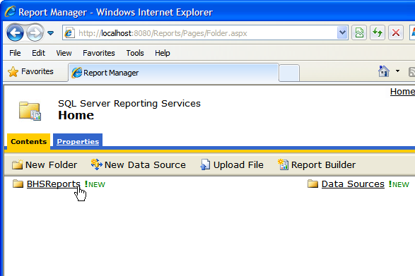

Select individual report whose security setting needs to be changed:
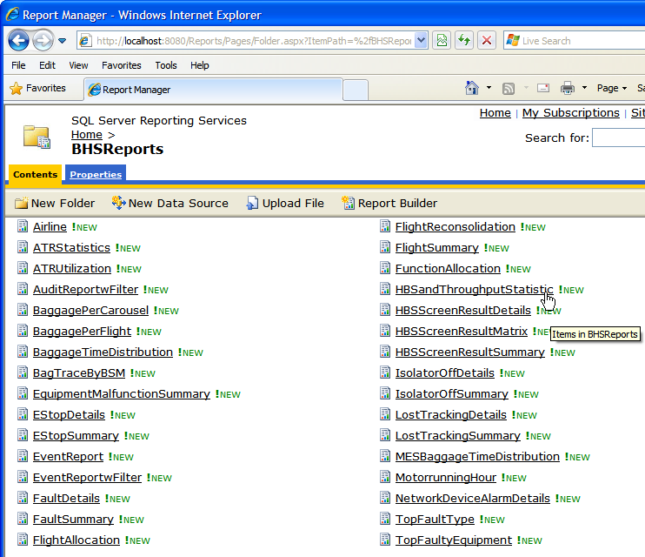

Then select “Properties” of report:
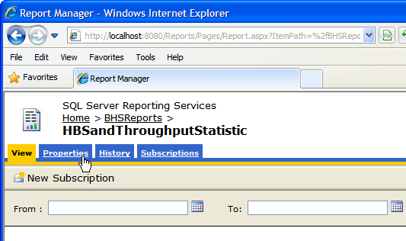

Select “Security” in the properties page:
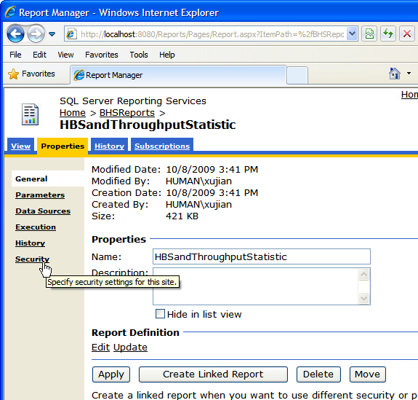

Select “Edit Item Security” in security page:
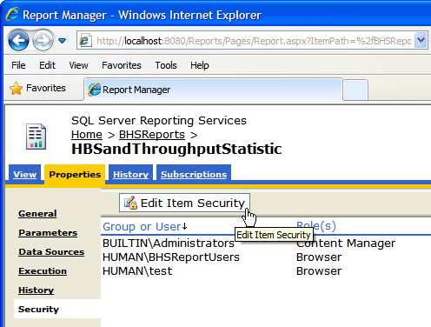

Click “OK” button on the pop-up window:
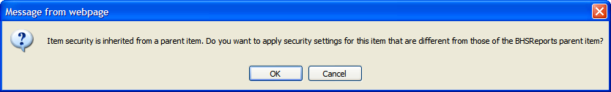

Then add or remove the Windows Users or User Groups for this report:
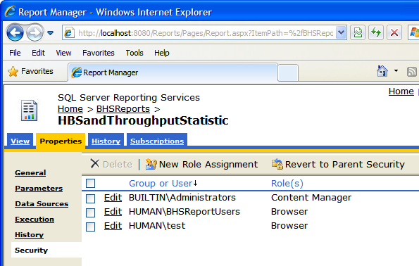

After above report security is set, if you access the reports from web browser, then you have to enter the right user name and password for authentication:
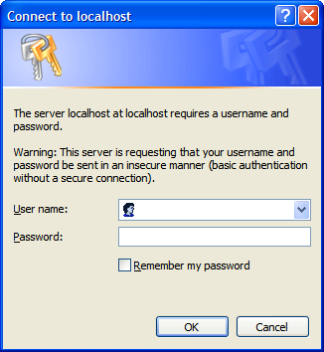

For printing report by using PALS.ReportViewer application, refer to chapters 1.2 below.

PALS.ReportViewer Multi-Level User Authentication

Reporting Service Authentication Configuration in Workgroup Server
In order for multi-level user authentication works properly in Domain and Workgroup environment, both RSWindowsBasic and RSWindowsNTLM authentication types must be set in MS SQL Server 2008 Reporting Service rsreportserver.config file as below:
<Authentication>
<AuthenticationTypes>
<RSWindowsBasic/>
<RSWindowsNTLM/>
</AuthenticationTypes>
<EnableAuthPersistence>true</EnableAuthPersistence>
</Authentication>

To configure Basic authentication on the report server, you edit XML elements and values in the RSReportServer.config file.

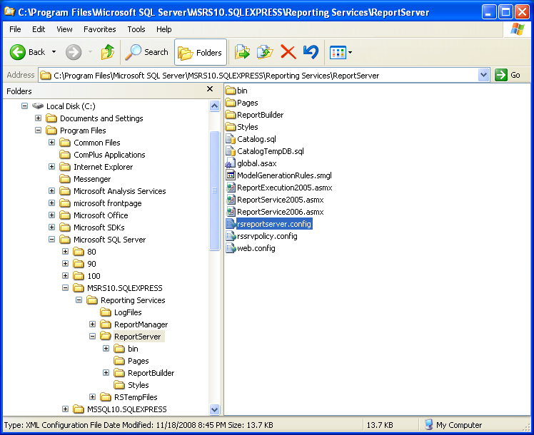

Open RSReportServer.config in a text editor and locate the setting of <Authentication>.

Copy following XML structures and Paste it over the existing entries for <Authentication>.
<Authentication>
<AuthenticationTypes>
<RSWindowsBasic/>
<RSWindowsNTLM/>
</AuthenticationTypes>
<EnableAuthPersistence>true</EnableAuthPersistence>
</Authentication>

Save the file and then restart the report server.

Note:
Do not change anything in the file RSReportServer.config other than XML node <Authentication>.

Security Setting in CFG_Reporting.XML File
There are two levels of security setting in PALS.ReportViewer application XML configuration file (CFG_Reporting.XML).
- Application Global Level Security Setting
- Individual Report Local Level Security Setting

Application Global Level Security Setting

<reportServerCredential userName="reportuser" password="BHSRep0rtUser" domain="csi" />

“reportServerCredential” setting used to specify the default user name and password for accessing reports. The default user name and password will be passed to Reporting Server by PALS.ReportViewer application for report user authentication if “authentication” setting of individual reports is missing or set to False.

Individual Report Local Level Security Setting

<report enabled="False" type="" name="Flight Summary Report">
<reportPath>/BHSReports/FlightSummary</reportPath>
<needDateTimeFormat>True</needDateTimeFormat>
<params>
<param name="SDO" datatype="DateTime" value="0" dateonly="True"></param>
</params>
</report>

<report enabled="True" type="Summary(M)" name="HBS Result Report">
<authentication>True</authentication>
<reportPath>/BHSReports/HBSScreenResultMatrix</reportPath>
<needDateTimeFormat>True</needDateTimeFormat>
<params>
<param name="DTFrom" datatype="DateTime" value="-24"></param>
<param name="DTTo" datatype="DateTime" value="0"></param>
</params>
</report>

“authentication” setting of individual report will inform PALS.ReportViewer application whether the 2nd level user authentication is needed for this report. If its value is “False” or setting is missing in the report configurations, then above application global default user name and password will be passed to Reporting Server for report user authentication. If its value is “True”, then when user preview this report, PALS.ReportViewer application will pop up below “Report User Authentication” window for user to enter the user name and password:
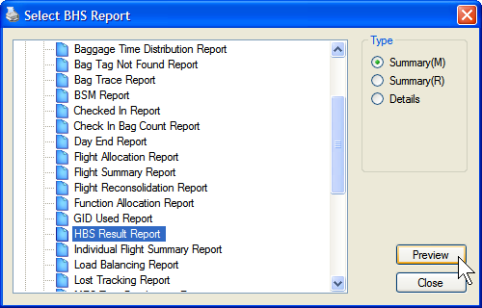

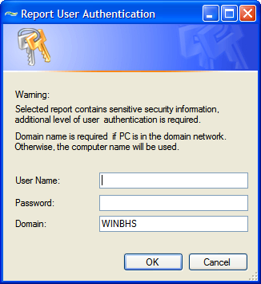

Report preview will be shown properly if user authentication is successful. Otherwise, “The request failed with HTTP status 401: Unauthorized” message will be pop-up as below:
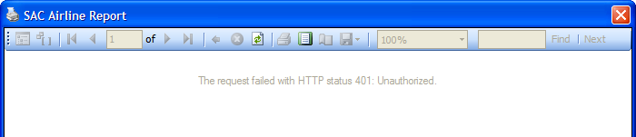

Or

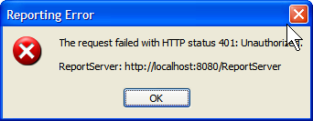

PALS Report XML Configuration File

<!—- PALS.ReportViewer Application Configuration-->
<application name="PALS.ReportViewer">
<!--Configuration Parameters that are divided into different configSet-->
<configSet name="Application.Initializer">
<company>Pteris Global</company>
<department>CSI</department>
<author>XuJian</author>
</configSet>
<log4net>
<!-- This section contains the log4net configuration settings -->
<!-- Define some output appenders -->
<appender name="RollingLogFileAppender" type="log4net.Appender.RollingFileAppender">
<param name="File" value="${PALS_LOG}\\ReportViewer.log" />
<param name="AppendToFile" value="True" />
<param name="DatePattern" value=".yyyyMMdd" />
<param name="RollingStyle" value="Date" />
<layout type="log4net.Layout.PatternLayout">
<param name="ConversionPattern" value="%d %-5p - %m%n" />
</layout>
</appender>
<!-- Setup the root category, add the appenders and set the default level -->
<root>
<!-- Level value can be ALL, DEBUG, INFO, WARN, ERROR, FATAL, OFF -->
<level value="OFF" />
<appender-ref ref="RollingLogFileAppender" />
</root>
</log4net>

<configSet name="Reporting">
<!--
Global Report Server URL. Individual report can has own reportServerUrl node, so that your
can print the reports that are located in the different report servers. If the individual report
don't have reportServerUrl node, this global report server URL will be used.
-->
<reportServerUrl>http://localhost:8080/ReportServer</reportServerUrl>
<!--
User identity of log onto reporting server. If userName is empty, then Windows authentication
of current logged in user on client computer will be used for logging onto reporting server. Otherwise,
the given username and password will be passed to reporting server for authentication.
If reporting server is domain node, then the value of attribute "domain" should be domain name.
If reporting server is workgroup server, then the value of attribute "domain" should be computer
name of reporting server.
Note:
1. Empty user name should be assigned for SQL Server 2005 Reporting Service;
2. Actual user name, password and domain should be assigned for SQL Server 2008 Reporting Service;
3. DO NOT ASSIGN ADMINISTRATOR USER NAME AND PASSWORD IN THIS FILE.
-->
<reportServerCredential userName="reportuser" password="BHSRep0rtUser" domain="csi" />
<!--
previewZoom attribute mode: 0 - FullPage, 1 - PageWidth, 2 - Percent;
attribute percent: integer value of zoom percentage. Percentage will only be used when mode attribute is Percent
-->
<previewZoom mode="2" percent="100" />
<!-- Set the display mode of ReportViewer object. True: PrintLayout, False: Normal Layout. -->
<showPrintLayout>False</showPrintLayout>
<!-- autoCloseViewer decide whether the report window to be closed automatically or not when it lose focus. -->
<autoCloseViewer>False</autoCloseViewer>
<!-- reportListStyle, 1: ListBox, 2: TreeView -->
<reportListStyle>2</reportListStyle>
<!-- displaySingleGroupName decide whether the group name is shown in the TreeView if there is only one report group -->
<showSingleGroupName>False</showSingleGroupName>

<!-- dateFormat and timeFormat are used to define the Date or Time format string.
attribute "valueType" has two valid settings: CultureDefault & CultureCustomized.
CultureDefault - To inform PALS.ReportViewer to pass the defautl
format string of culture used by current thread;
CultureCustomized - To inform PALS.ReportViewer to pass user selected (customized)
format string of culture used by current thread;

attribute "valuePart" has four valid settings: ShortDatePattern & ShortTimePattern.
ShortDatePattern - (Recommended) Use Short Date format string, e.g. dd/MM/yyyy
LongDatePattern - Use Long Date format string, e.g. dddd, MMMM dd, yyyy
ShortTimePattern - Use Short Time format string, e.g. h:m:s tt
LongTimePattern - (Recommended) Use Long Time format string, e.g. hh:mm:ss tt

If dateFormat and timeFormat are missing or assigned with invalid setting, but report template
requires the Date & Time format string as the report parameters, then the CultureCustomized
short date and long time format string will be used.
-->
<dateFormat valueType="CultureCustomized" valuePart="ShortDatePattern"></dateFormat>
<timeFormat valueType="CultureCustomized" valuePart="LongTimePattern"></timeFormat>

<!-- #############################################################################################
XML Configuration Guide:
Report Group Rules:
===================
1. Multiple reports node can be defined by multiple "reports" node, but their "group" attribute
must be different.
2. If reports "group" attribute is empty, the default name "Group?" will be displayed on
BHS_ReportViewer GUI. "?" here is the sequence number that reports node in the XML file.
3. The same report name and type can be appeared in the different report groups, but not in
the same group.
4. The reports group name or report name must not contain "\" string.

Report Name & Type Rule:
========================
1. If the enabled attribute of report node is Fault, this report name will not be displayed
in the report list on the BHS_ReportViewer application GUI.
2. The same report name can be assigned to the name attribute of report node. But their
type attribute must be assigned with different value, and it can not be empty value. The
same report name can have up to 6 types.

Report Parameter Rule:
======================
1. params node defines the default value of report parameters. If they are defined at here,
these default value will be passed to report template. You can also ommit them. If do so,
there is no default values will be passed to report template.
2. The valid param node datatype are:
- String
- Integer
- Boolean
- Double
- DateTime
3. If the data type of param node is DateTime, it's value represents a number of whole and
fractional hours offset from the current date and time. It can be negative or positive
value.
4. If the data type of param node is DateTime, and the attribute "dateonly" value is "True",
e.g.:
<report enabled="True" type="" name="Automatic RF Reader Or Writer Report">
<authentication>False</authentication>
<reportPath>/BHSReports/AutomaticRFReaderOrWriter</reportPath>
<needDateTimeFormat>True</needDateTimeFormat>
<params>
<param name="DTFrom" datatype="DateTime" value="-24" dateonly="True"></param>
<param name="DTTo" datatype="DateTime" value="0" dateonly="False"></param>
</params>
</report>
then only date value will be assigned to report parameter. But if it is "False" or not
given, then both date and time values will be assigned to report parameter.
5. needDateTimeFormat setting used to inform PALS.ReportViewer application that the report
template has both "DFormat" and "TFormat" parameters. Hence, the date and time format
string defined by above "dateFormat" and "timeFormat" setting will be passed into
report template. If needDateTimeFormat is not defined, then no date/time format string
will be passed to report template.
6. The name of report parameter "DFormat" and "TFormat" must be used by report templates to
receive the Date & Time format from PALS.ReportViewer application.
7. authentication setting is used to control the another level of user authentication requirement.
If its value is "False" or not given, then the user name and password defined in
global setting "reportServerCredential" will be passed to report server. If its value
is "True", then PALS ReportViewer application will pop up a user log on window to ask
for the user name and password and then pass them to report server for authentication.
############################################################################################# -->

<!-- Report Group and Individual Report Defination: -->
<reports group="SAC">

<report enabled="True" type="" name="Airline Report">
<authentication>True</authentication>
<reportPath>/BHSReports/Airline</reportPath>
<needDateTimeFormat>True</needDateTimeFormat>
</report>

<report enabled="True" type="" name="ATR Statistics Report">
<reportPath>/BHSReports/ATRStatistics</reportPath>
<needDateTimeFormat>True</needDateTimeFormat>
<params>
<param name="DTFrom" datatype="DateTime" value="-24"></param>
<param name="DTTo" datatype="DateTime" value="0"></param>
</params>
</report>

<report enabled="False" type="BSM" name="Checked In Report">
<reportPath>/BHSReports/CheckedInBSM</reportPath>
<needDateTimeFormat>True</needDateTimeFormat>
<params>
<param name="SDO" datatype="DateTime" value="0" dateonly="True"></param>
<param name="Flight" datatype="String" value=""></param>
</params>
</report>

<report enabled="False" type="Flight" name="Checked In Report">
<reportPath>/BHSReports/CheckedInByFlight</reportPath>
<needDateTimeFormat>True</needDateTimeFormat>
<params>
<param name="SDO" datatype="DateTime" value="0" dateonly="True"></param>
</params>
</report>

<report enabled="False" type="" name="Check In Bag Count Report">
<reportPath>/BHSReports/CheckInInputSummary</reportPath>
<needDateTimeFormat>True</needDateTimeFormat>
<params>
<param name="DTFrom" datatype="DateTime" value="-24"></param>
<param name="DTTo" datatype="DateTime" value="0"></param>
</params>
</report>

<report enabled="True" type="Summary(M)" name="HBS Result Report">
<authentication>True</authentication>
<reportPath>/BHSReports/HBSScreenResultMatrix</reportPath>
<needDateTimeFormat>True</needDateTimeFormat>
<params>
<param name="DTFrom" datatype="DateTime" value="-24"></param>
<param name="DTTo" datatype="DateTime" value="0"></param>
</params>
</report>

<report enabled="True" type="Summary(R)" name="HBS Result Report">
<authentication>True</authentication>
<reportPath>/BHSReports/HBSScreenResultSummary</reportPath>
<needDateTimeFormat>True</needDateTimeFormat>
<params>
<param name="DTFrom" datatype="DateTime" value="-24"></param>
<param name="DTTo" datatype="DateTime" value="0"></param>
</params>
</report>

<report enabled="True" type="Details" name="HBS Result Report">
<authentication>True</authentication>
<reportPath>/BHSReports/HBSScreenResultDetails</reportPath>
<needDateTimeFormat>True</needDateTimeFormat>
<params>
<param name="DTFrom" datatype="DateTime" value="-24"></param>
<param name="DTTo" datatype="DateTime" value="0"></param>
</params>
</report>
……
</reports>

<reports group="MDS">
<report enabled="True" type="Summary" name="Emergency Stop Report">
<reportPath>/BHSReports/EStopSummary</reportPath>
<needDateTimeFormat>True</needDateTimeFormat>
<params>
<param name="DTFrom" datatype="DateTime" value="-24"></param>
<param name="DTTo" datatype="DateTime" value="0"></param>
</params>
</report>

<report enabled="True" type="Details" name="Emergency Stop Report">
<reportPath>/BHSReports/EStopDetails</reportPath>
<needDateTimeFormat>True</needDateTimeFormat>
<params>
<param name="DTFrom" datatype="DateTime" value="-24"></param>
<param name="DTTo" datatype="DateTime" value="0"></param>
</params>
</report>

<report enabled="True" type="" name="Top Faulted Equipment Report">
<reportPath>/BHSReports/TopFaultyEquipment</reportPath>
<needDateTimeFormat>True</needDateTimeFormat>
<params>
<param name="DTFrom" datatype="DateTime" value="-168"></param>
<param name="DTTo" datatype="DateTime" value="0"></param>
<param name="Rank" datatype="Integer" value="10"></param>
</params>
</report>

<report enabled="True" type="" name="Top Faults Report">
<reportPath>/BHSReports/TopFaultType</reportPath>
<needDateTimeFormat>True</needDateTimeFormat>
<params>
<param name="DTFrom" datatype="DateTime" value="-168"></param>
<param name="DTTo" datatype="DateTime" value="0"></param>
<param name="Rank" datatype="Integer" value="10"></param>
</params>
</report>

……
</reports>
</configSet>
</application>

